<Project Name>
project charter
LITE Version .3
6/1/2006

VERSION HISTORY

Version # | Implemented  By | Revision  Date | Approved  By | Approval  Date | Reason
0.1 | Robin Tracy | 05/16/2006 |  | 5/16/06 | Initial Project Charter draft
0.2 | Robin Tracy | 5/22/2006 |  | 5/22/06 | Updates per Customer
0.3 | Robin Tracy | 6/1/06 |  | 6/1/06 | Final approval updated with CCID comments

Project Charter
Full Template | Lite Template
Introduction
Purpose of Project Charter
Project and Product Overview | Project and Product Overview
Justification
Business Need
Public Health/Business Impact
Strategic Alignment
Scope | Scope
Objectives | Objectives
High-Level Requirements | High-Level Requirements
Major Deliverables | Major Deliverables/Milestones
Boundaries
Duration | Duration
Timeline | Timeline
Executive Milestones
Budget Estimate | Budget Estimate
Funding Source | Funding Source
Estimate | Estimate
High-Level Alternatives Analysis
Assumptions, Constraints and Risks
Assumptions, Constraints and Risks
Constraints
Risks
Project Organization
Roles and Responsibilities
Stakeholders (Internal and External)

TABLE OF CONTENTS
1 Introduction 3
1.1 Purpose of LITE Project Charter 3
2 project And Product Overview 3
3 Alternatives 3
4 Scope 3
4.1 Objectives 3
4.2 High-Level Requirements 3
4.3 Major Deliverables/Milestones 3
5 Duration 3
5.1 Estimated Timeline 3
6 budget Estimate 3
6.1 Funding Source 3
6.2 Estimate 3
7 project Charter approval 3
APPENDIX A: REFERENCES 3
APPENDIX B: KEY TERMS 3

Introduction

Purpose of LITE Project Charter
The GAP Research Compendium LITE Project Charter documents and tracks the necessary information required by decision maker(s) to approve the project for funding.
The intended audience of the GAP Research Compendium LITE Project Charter is the project sponsor and senior leadership.

project And Product Overview
The proposed project will provide a compendium of the research projects that GAP conducts in 25 countries around the world. Having a catalogue of the projects that can be searched by country, technical area, and other variables will allow staff to share information more efficiently and effectively across countries. Thus, allowing staff in one country to know what projects others have done elsewhere, without starting from the very beginning of each project.
Public Health Impact – By increasing the ability of staff in participating GAP countries to share project information, successful projects can be more easily repeated in other locations. It will also be easier to identify areas where specific project types are missing, and more efficiently address the HIV/AIDS needs across all of the GAP countries.
The project duration will depend on the requirements gathered and the estimated project budget is TBD

Alternatives
Prior to initiating this project 4 alternative systems were reviewed and a gap analysis conducted to verify if they would be candidates for use.
a. Healthimpact.net – System used for Budgets and did not meet the searchable requirement necessary to make project successful. Therefore, Healthimpact.net cannot be used.
b. IRB Online – Used for tracking and approval of protocols through the IRB process. Protocols are outputs of projects and not all projects become protocols. Also, did not meet the project data entry criteria necessary to make project successful (eg does not allow for non-IRB projects to be entered and was lacking in variables needed). Therefore, IRB Online cannot be used.
c. STDPTS – Used as a template for the framework, but unable to meet the project data entry criteria necessary to make project successful. Therefore, STDPTS cannot be used.
d. MS Project – An off the shelf software tool used to track schedule and cost of projects. Therefore, cannot be used.

Scope

Objectives
The objectives of the GAP Research Compendium are as follows:
- The capture of project information for GAP to include research projects;
  - Project Title
  - Protocol Number
  - IRB Classification: research or non-research
    - If research then exempt or involves human subjects
  - IRB Deferral: yes or no
    - If yes then write in name of deferral institution
  - Country
  - Project Contact Person
  - Project Description (summary)
  - Technical area (15 choices, and write in Other)
  - Start Date
  - End Date
  - Related publications: type of publication (abstract, article, MMWR, chapter, other CDC publication, other)
    - For articles – title, first author, link
    - For abstracts – title, first author, meeting
- The ability to track the project status;
- The ability to associate project outcomes with projects;
- The ability to search by country and/or technical area;
- The ability to report on project information

High-Level Requirements
The following table presents the requirements that the project’s product, service or result must meet in order for the project objectives to be satisfied.
Req. # | I Requirement Description
1 | The ability to enter project information as defined by the business
2 | The ability to track project status
3 | The ability the associate project outcomes with projects for sharing information
4 | The ability to report on projects as defined by the business
5 | The ability to search by country and/or technical area

Major Deliverables/Milestones
Major Deliverable | I Deliverable Description
Project Charter | JIdentifies the project need, cost, duration and creates acceptance to begin project
Project Management Plan | Provides the stakeholders with risk, issue and other project information related to their project
Project Schedule | Provides the stakeholders and project team with an understanding of tasks to be completed and timeframes associated with those specified tasks
Requirements Review | Walkthrough conducted by Business Analyst to achieve approval from Business as to th proposed project requirements
Design Review | Walkthrough conducted by Business Analyst to achieve approval from Business as to the proposed project design
User Acceptance Testing | Conducted in conjunction with Project manager, Business Analyst, and QA that constitutes business acceptance of the product
Deployment Plan | Identifies to the stakeholders and project team tasks necessary to move application into production

Duration

Estimated Timeline

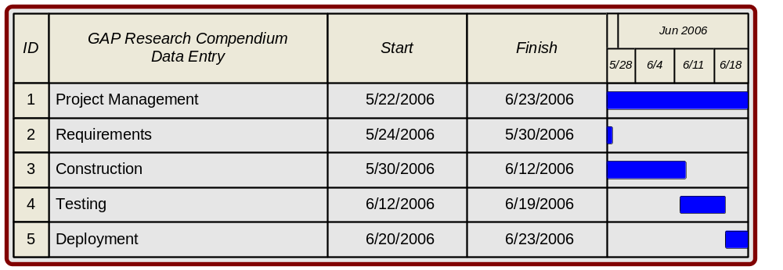

budget Estimate

Funding Source
TBD

Estimate
This section provides a summary of estimated spending to meet the objectives of the GAP Research Compendium project as described in this Project Charter. This summary of spending is preliminary, and should reflect costs for the entire investment lifecycle. It is intended to present probable funding requirements and to assist in obtaining budgeting support.

project Charter approval
The undersigned acknowledge they have reviewed the LITE Project Charter and authorize and fund the GAP Research Compendium project. Changes to this LITE Project Charter will be coordinated with and approved by the undersigned or their designated representatives.

Signature: |  | Date:
Print Name: | SME
Title: | Business Steward
Role:

Signature: |  | Date:
Print Name: | Max Mirabito
Title: | Technical Steward
Role:

Signature: |  | Date:
Print Name: | Robin Tracy, PMP
Title: | Project Manager
Role:

Signature: |  | Date:
Print Name: | GAP Leadership
Title: | Project Sponsor
Role:

APPENDIX A: REFERENCES
The following table summarizes the documents referenced in this document.
Document Name and Version | Description | Location
N/A

APPENDIX B: KEY TERMS
The following table provides definitions for terms relevant to this document.
Term | Definition
Assumption | A factor that, for planning purposes is considered to be true, real or certain without proof or demonstration.
Constraint | An applicable restriction or limitation, either internal or external to a project that will affect the performance of the project.
Deliverable | Any unique and verifiable product, result or capability to perform a service that must be produced in order to complete a process, phase or project.
Executive Milestone | A significant accomplishment or event in the project scope, such as completion of a major deliverable (e.g., product releases, user acceptance).
Project | An endeavor to create a unique product or service.
Risk | An uncertain event or condition that, if it occurs, has a positive or negative affect on a project’s objectives.
GAP | Global Aids Program

